Railroad GHG Emissions Accounting with Biofuels
Wayne A. Kennedy – Railroad Consultant
Steve Fritz – Southwest Research Institute
Veronica Bradley – Clean Fuels Alliance America
Sarah Elsokkary – Arcadis
Rajani Modiyani – Chevron REG
Abstract

The six North American Class I railroads collectively consumed 3.6 billion gallons of diesel fuel in 2023. All Class I railroads have partnered with SBTi (Science Based Targets) to aggressively reduce GHG emissions by 2030. The uptake in the use of biofuels has been increasing in recent years to help meet SBTi goals. This paper outlines various approaches, challenges, and uncertainty related to how North American Class I railroads will factor biofuel use from a GHG accounting standpoint.

There is likely a need for the railroad industry to standardize around a common GHG accounting methodology related to biofuels.

Word Cloud - What’s the Focus for Rail?

The rail industry is relatively new to the world of setting SBTi goals and setting aggressive targets for GHG emissions reduction. The terminology is somewhat new and can be confusing to the uninitiated. The word cloud shown in Figure 1 is a sampling of available nomenclature, to the average railroader who is trying to make an impact, it’s all about fuel conservation, burning less carbon fuels emits less carbon into the atmosphere, and increasing the uptake of biofuels which have a much lower carbon intensity.

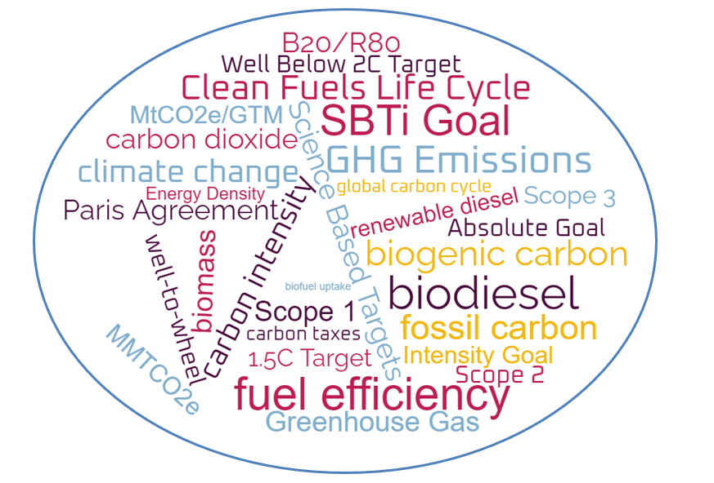
Figure 1 - GHG Emissions Reduction Word Cloud for the Rail Industry

Fossil Fuel Versus Biogenic Carbon - What’s the Difference?

What are fossil carbon and biogenic carbon?

Fossil carbon and biogenic carbon have different origins and implications for the global carbon cycle and climate change. Fossil carbon is the carbon that is released from the combustion of fossil fuels, such as coal, oil, and natural gas, whereas biogenic carbon is the carbon that is released from the combustion of biomass, such as wood, crops, and waste.

How do fossil carbon and biogenic carbon affect the carbon cycle?

The carbon cycle is the process by which carbon moves between the atmosphere, land, oceans, and living organisms.Fossil carbon adds new carbon to the atmosphere that was previously stored underground for millions of years, whereas biogenic carbon recycles carbon that was already part of the atmosphere and the biosphere.

Fossil carbon increases the concentration of carbon dioxide (CO2) in the atmosphere, which is the main greenhouse gas that causes global warming. Biogenic carbon does not increase the net amount of CO2 in the atmosphere, as long as the biomass is regrown or replaced. Figure 2 illustrates the difference between these two sources in the carbon cycle.

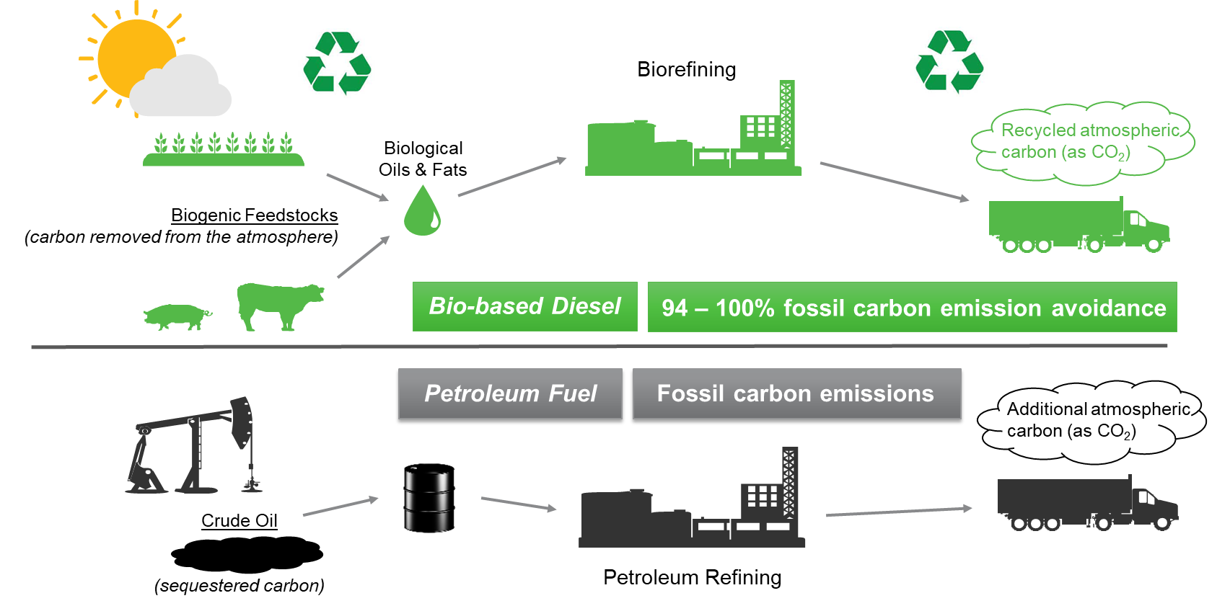
Figure 2 - Biogenic versus Fossil Fuel Carbon Cycle Diagram

SBTi Scope Emissions and Reduction Goals for the Industry
The Science Based Targets initiative (website www.sciencebasedtargets.org) was established in 2015 to help companies set emission reduction targets in line with climate science and the Paris Agreement goals. The Paris Agreement’s long-term temperature goal is to keep the rise in mean global temperatures to well below 2 degrees Celsius above pre-industrial levels, and preferably limit the increase to 1.5 degrees Celsius. As of June 2024, there are almost 8,000 companies taking action.
Figure 3 shows the differing scopes and a brief description of each scope. Scope 1 covers direct emissions from owned or controlled sources, diesel fuel burned in locomotives in this case of railroads, which generally account for 95% of Scope 1 emissions, from the combustion of diesel and biofuels, also called tank to wheel, in North America (CN is an exception at a lower 85% due to their shipping and trucking assets). Scope 2 covers indirect emissions from the generation of purchased electricity, steam, heating and cooling consumed by the reporting railroad company at all of their maintenance shops, crew room locations, yard / fueling facilities and headquarter locations. Scope 3 includes all other indirect emissions that occur in a company's value chain such as disposal of used railroad ties and steel rail and wheels as an example. It also includes the well to tank (the upstream portion) of fuels including extraction, production and transportation of fuels.
There are two main metrics used for GHG emission measures; an absolute metric which is directly tied to how much diesel fuel is burned and is referenced in metric tons of CO₂ equivalent, and the more common measure based on intensity using either gross ton miles or revenue ton miles, as a base measure producing an intensity rate which is volume neutral. Typical units used are MtCO₂e/GTM (metric tons of CO₂ equivalent per gross ton mile). A ton mile is a unit of measure used in transportation and logistics which uses the weight of a shipment multiplied by the distance it is hauled. For example, one ton mile is equivalent to one ton of freight hauled over a distance of one mile. Gross ton miles include the weight of the entire train including freight, container, cars, and locomotives. Revenue ton miles include the weight of the customer revenue generating freight.
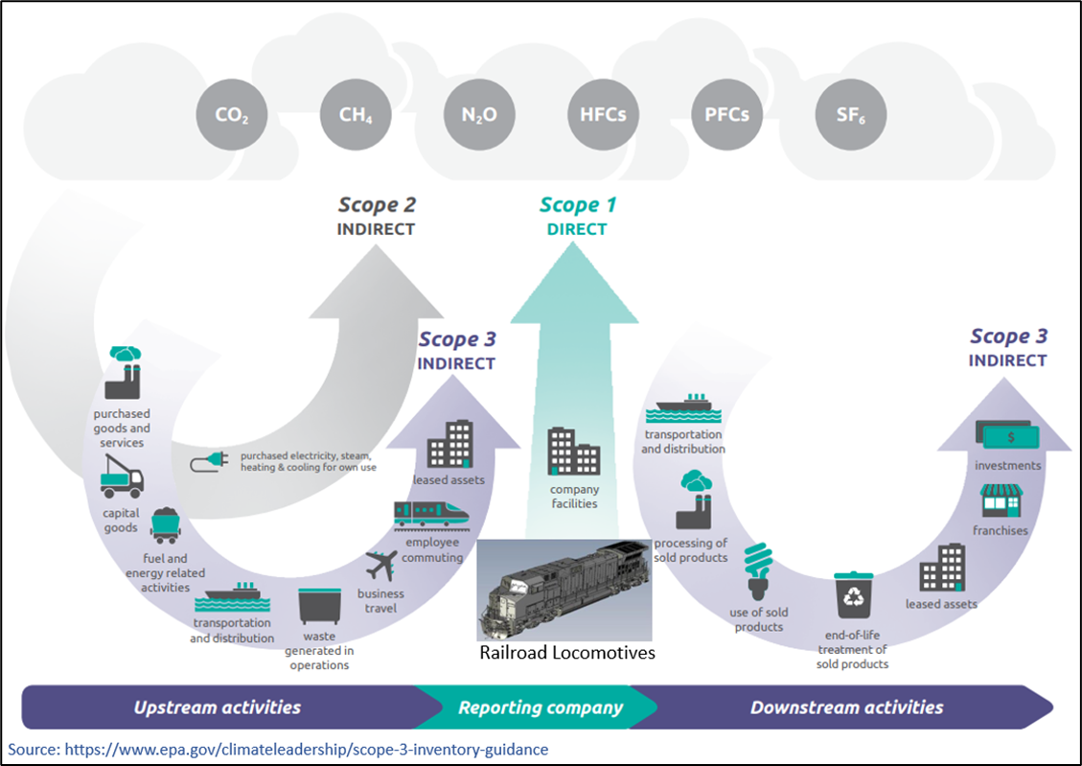
Figure 3 – Emissions Scope Definitions

Table 1 is directly from the SBTi website and shows all Class 1 goals. The goal dates vary but are mostly centered around the 2030 time frame. They have all chosen a “well below 2 degrees Celsius” goal for limiting long term global warming with a 1.5 degrees Celsius goal recently approved for UP. Further, the CN, CPKC and UP have committed to a Net-Zero goal by 2050.
Both BNSF and UP railroads have chosen the Absolute goal measure, where future growth and volume increases will make their GHG reduction goals more challenging to achieve. Though to-date, traffic volume loss of 14% as measured by Gross Ton Miles or GTMs has helped both railroads make significant progress towards achieving their SBTi goals.

Class I Railroads and Description of GHG Emissions Reduction Goals
All railroads must reevaluate and submit more ambitious targets 5 years from the date the current target is published. In response to increasing urgency for climate action and the success of science-based targets to date, the SBTi unveiled a new strategy in late 2021 to increase minimum ambition in corporate target setting from 'well below 2 degrees Celsius' to 1.5 degrees Celsius above pre-industrial levels.¹ Union Pacific was the first railroad to have their 1.5 degree Celsius goal approved by SBTi in early 2024, moving from a 26% to a 50% absolute reduction in GHG emissions.
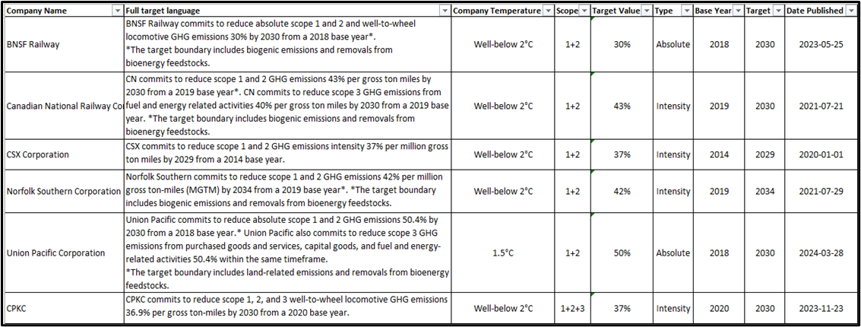
Table 1 – SBTi Goals by Railroad

Figure 4 shows an equal weighting of the four Class I railroads that have chosen an emissions intensity goal. Note that improvement has stalled in the last three years and on average, they are now 15% above their SBTi glideslope goal. Current year is an estimate based on YTD fuel efficiency performance reported during quarterly earnings.
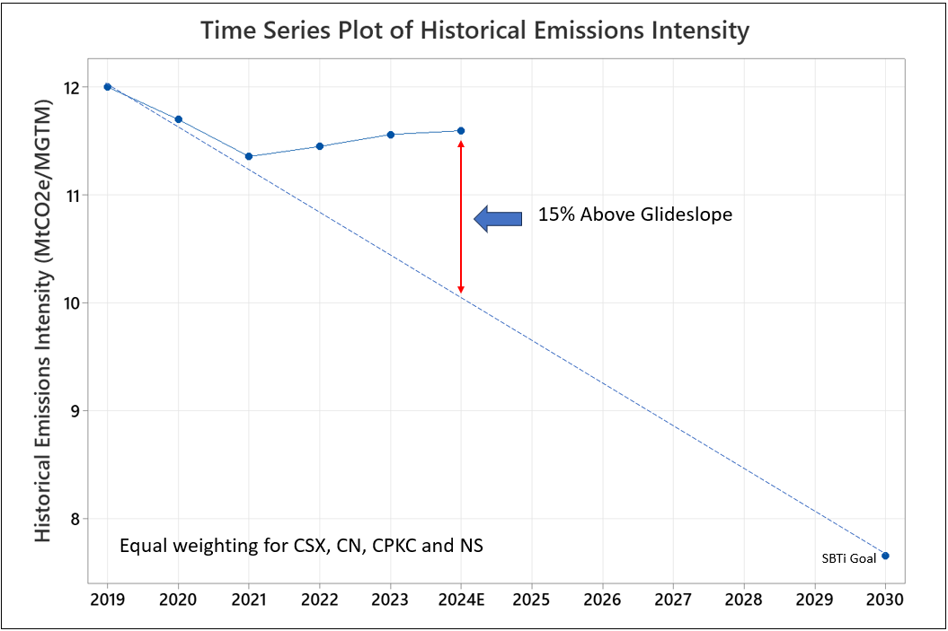
Figure 4 – Average Performance of Four Intensity Based Railroads Showing Glideslope to SBTi Goal
Figure 5 shows an equal weighting of the two Class I railroads that have chosen an absolute emissions goal. Given the significant drop in traffic volumes since the baseline year of 2018, it is not surprising that they are roughly on track for their required SBTi glideslope goal. Current year is an estimate based on YTD fuel efficiency performance reported during quarterly earnings.
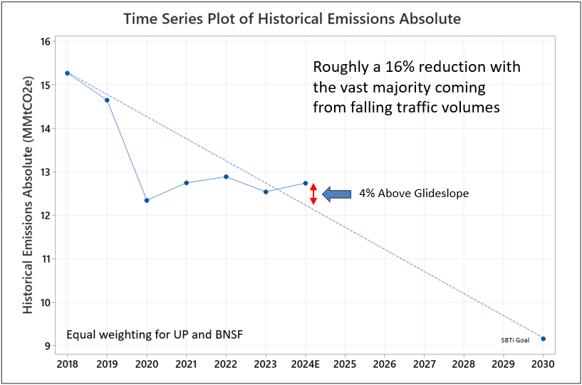
Figure 5 – Average Performance of Two Absolute Based Railroads Showing Glideslope to SBTi Goal

Historical Fuel Efficiency Industry Performance
The rail industry commonly uses a fuel efficiency measure of Gallons per Thousand Gross-ton-Miles which has been tracked for many decades. Figure 6 shows each of the seven Class 1 railroads going back to 2000. Notice the Canadian railroads have generally been the best performers and starting in 2013 both distanced themselves from their US peers.
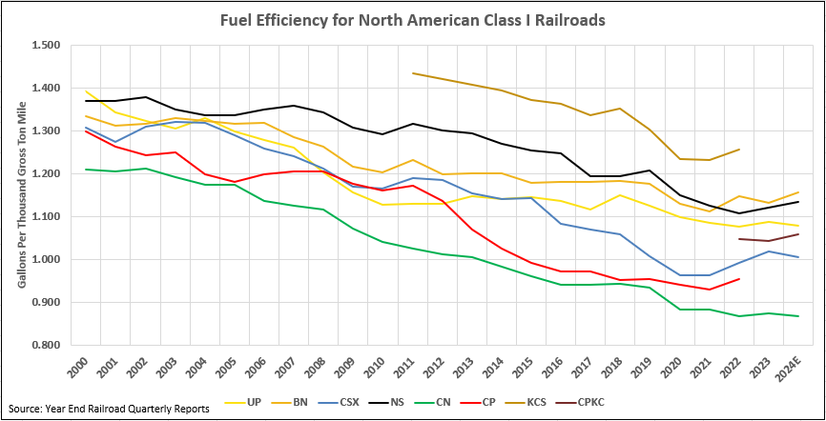
Figure 6 – Fuel Efficiency for Class 1 Railroads

Figure 7 shows the weighted average performance of the Class I railroads, so it is an industry performance metric that indicates a 0.9% annual improvement going back to 2011. If we look at the aggregate SBTi goals out to 2030 and the glide slope required for the industry to achieve that goal, it will require from 2022 forward, a 6.8% year over year improvement in fuel efficiency to meet the SBTi targets. Whereas on the current historical glide slope, that would create a 40% percent gap between where railroads need to be and where they likely will be on their current trajectory or historical glide slope. Per the more challenging 1.5 degree Celsius SBTi goals to be approved in the future (similar to UP), this will likely mean the slope of the line shown in Figure 6 will become even steeper.

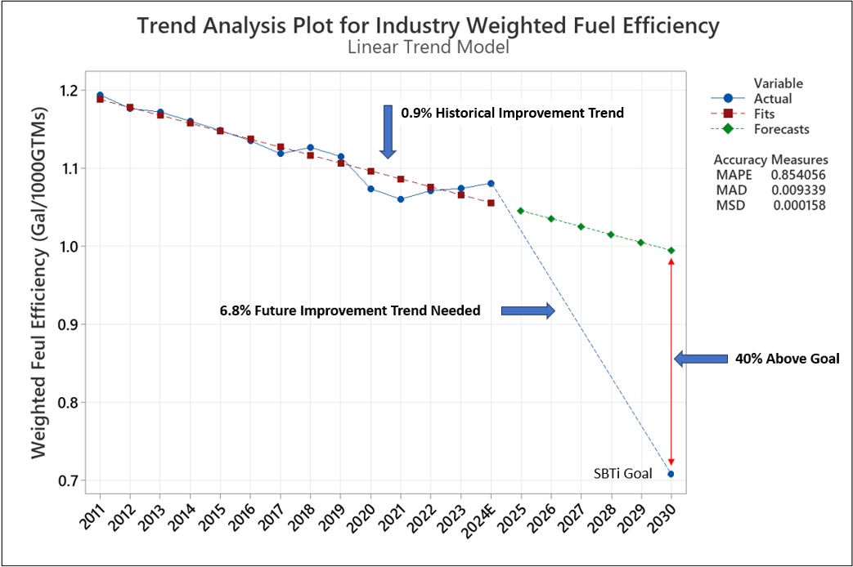
Figure 7 – Historical Rail Industry Glide Slope versus SBTi 2030 Goal

Current Biofuel Uptake for Class I Railroads

Each railroad publishes Sustainability reports and provides CDP Disclosures which provide approximate percentages of biodiesel (and likely some renewable diesel) being purchased for a given reported year. Table 2 shows the current status of each Class I railroad.

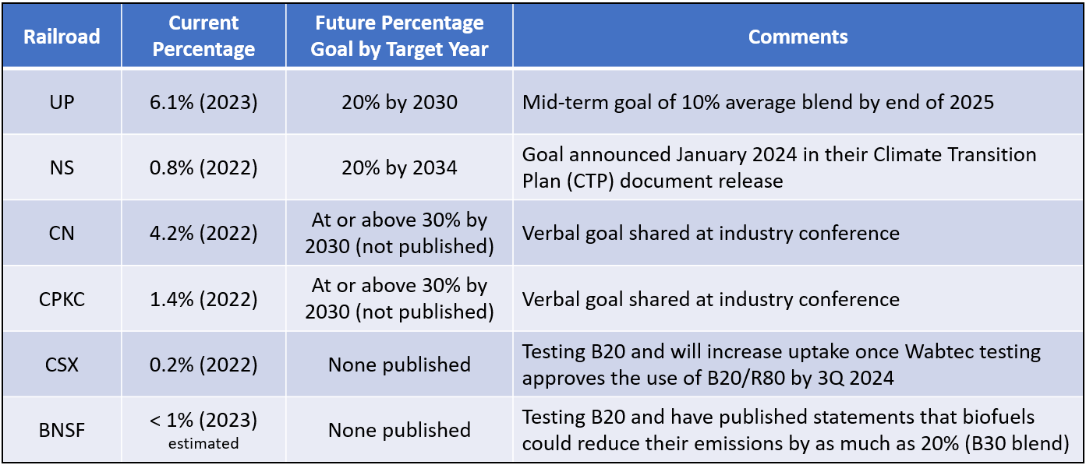
Table 2 - Biofuel Blend Percentage by Class I Railroad ^{2,3,4,5,6,7}

UP and CN are leaders in their respective country in terms of having high levels of biofuel uptake. The other railroads have various lower level blends ranging from 0.2% to 1.4% based on the most recent reporting available.

One potential reason for a slower adoption is that one of the leading locomotive OEM’s are still in the process of officially approving up to a B20 blend level. Tentative approval is expected by the end of 2024 with final approval estimated another two years past that time.

Different Requirements by Country

Canada has a more stringent reporting for renewable fuels on the supplier like the California LCFS program. These regulations require fuel producers and importers to have an average renewable fuel content of at least 2% based on the volume of diesel fuel and heating distillate oil that they produce or import into Canada. - The regulation allows for the trading of compliance credits between suppliers, allowing suppliers who have surpassed the regulatory % to sell off % points to suppliers who are lagging. These regulations do not affect reporting of consumers of renewable fuels.

For Carbon taxes - there is a federal minimum carbon tax in Canada which as of April 2023 was $65 CAD per tonne of CO2e and is set to increase to $170 CAD per tonne in 2030. At the provincial level they must follow the federal carbon pricing mechanism but can have a higher tax than the federally mandated one but not a lower one. Large corporations receive pretty heavy exemptions to protect from foreign competitors who don't pay carbon prices. This could be an incentive for Canadian roads to use less carbon intensive fuels.

Railroad Corporate GHG Accounting Including Biofuels

Calculating the CO2 mass emission rate from a locomotive is relatively straightforward, and is part of the EPA Federal Test Procedure. Measuring emissions “out the stack” is approximately 75g CO2/MJ compared to the CARB carbon intensity (CI) of 100.45 gCO2/MJ for a baseline of petroleum diesel fuel. Why the difference? While the “out of stack” or use phase emissions is captured in the EPA Federal Test Procedure, carbon intensity captures the entire “life cycle” emissions of the fuel, incorporating emissions from the production of the feedstock, whether that’s petroleum or of bio-based origin as well as other process and energy inputs to the fuel production phase, the transportation between all these steps and the final distribution and use of the fuel. While the stack CO2 emissions for a locomotive will measure roughly the same regardless of whether the fuel going into the engine is petroleum or biofuel based, the accounting methods by which traditional greenhouse gas accounting programs assess the environmental impact of the fuel-related emissions distinguish between fossil and biogenic CO2. It is within this distinction that biofuels generate the majority of their GHG benefits to end users like the rail industry.

All carbon on Earth is stored in one of many reservoirs and flows between these different reservoirs in an exchange called the carbon cycle, wherein carbon moves from one reservoir to another at different rates. While most of the Earth’s carbon is stored in rocks, it is also stored in varying amounts in the ocean, atmosphere, plants, soil, and fossil fuels. The slow carbon cycle moves carbon on geological timescales, whereas the fast carbon cycle moves carbon through biological processes on timescales more in line with animal and plant lifespans. The burning of fossil fuels has sped up the slow carbon cycle moving subterranean stores of carbon into the atmosphere causing human-induced climate change. Biofuels use carbon from the fast carbon cycle, wherein the biogenic feedstocks have recently taken up CO2 from the atmosphere in their production that is then returned to the atmosphere upon the combustion of the fuel.
The carbon intensity of biofuels thus distinguishes between fossil and biogenic carbon and is the sum of the fossil CO2 emissions estimated across the entire life cycle of the fuel as well as other GHGs produced in the fuels life cycle as illustrated in Figure 8.
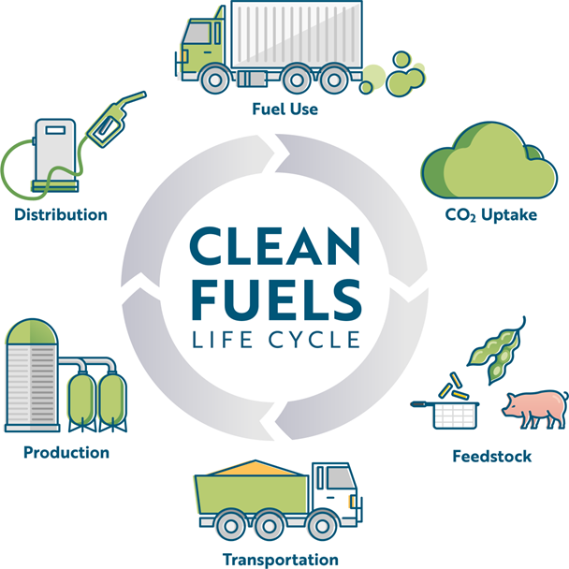
Figure 8 - Clean Fuels Life Cycle Diagram

When a company uses biofuels, it reduces their slow or fossil carbon emissions by switching to bio-based fuel. How much environmental benefit a given biofuel has in terms of carbon intensity is then compared to a petroleum baseline. For example, using the Department of Energy Argonne National Lab’s Greenhouse gasses, Regulated Emissions, and Energy use in Technologies (GREET) Model, soy-based biodiesel has a CI value of 23.2 kg CO2e/MMBTU while petroleum diesel has a CI of 95.9 kg CO2e/MMBTU. On a life-cycle basis, therefore, soy biodiesel reduces GHG emissions by 76%.
However, because the carbon intensity of a fuel is based on the fuel’s full life cycle, it cannot be used as an emissions factor to determine the associated scope 1 GHG emissions from its combustion. In addition to upstream emissions, carbon intensity scores, which are usually calculated in accordance with policy programs like California’s Low Carbon Fuel Standard, may include penalties associated with indirect impacts (e.g., land use change) and credits associated with avoided impacts (e.g., methane avoidance for use of landfill gas). These additional credits and debits further justify not using a carbon intensity score as an emission factor to calculate scope 1 or scope 3 emissions.
That said, a fuel’s carbon intensity score does contain the underlying data necessary to estimate scope 1 and 3 emissions from fuel combustion as they relate to scope 1 emissions for direct combustion of the fuel and scope 3 category 3 emissions from fuel activities not in other scopes (i.e., upstream emissions from feedstock extraction/production, fuel production, and transportation and distribution). Taking the GREET Model figures above, we find that the use phase or scope 1 emissions for petroleum diesel are 79.8 kg CO2e/MMBTU while those emissions for soy biodiesel are 4.0 kg CO2e/MMBTU, factoring in the fossil carbon from the methanol used to produce the fuel as well as other GHGs, including methane and nitrous oxide. This means switching from petroleum to soy-based 100% biodiesel reduces Scope 1 emissions by 95%. The balance of the carbon intensity values above, which were already corrected for indirect land use change penalties baked into the GREET model, are attributable to Scope 3 emissions. As such, soy biodiesel increases Scope 3 emissions by roughly 19% on an energy basis.
Unfortunately, as alluded to, there is no standardization in the corporate accounting world, or under SBTi for calculating the CI of biofuels or for how to translate that CI score into scope 1 and scope 3 emissions, so the use of the GREET model in this example is for illustrative purposes. Often, biofuels producers track the CI values attributed to their fuel pathways (feedstock + fuel conversion process) for each program they participate in. As such, the same fuel may have several different CI values attributed to it depending on which program the fuel producer participates in. This is because not only are there credits and debits added to the direct life cycle emissions of the fuel, but the level of detail a fuel producer can input into the direct emissions calculations varies by program. While one program may allow a fuel producer to reduce its fuel’s carbon intensity by purchasing renewable electricity on the grid, other programs may require that electricity be directly connected to the fuel production facility, preventing the producer from capturing the benefits of a lower carbon intense electrical grid mix.

These nuances of carbon intensity-based policy programs make it extremely difficult for both fuel producers and consumers alike to have certainty in quantifying the emissions benefits of their fuels. Because the regulatory regimes to lower the carbon intensity of fuels were developed concurrently but separately from the development of emission factors for these fuels, both the renewable fuel industry and fuel consumers are left with an oversupply of information without concrete guidance as to best practices on reconciling carbon intensity methodologies with emission factor methodology.
GLEC Framework and the GHG Protocol

One group based in the European Union that is trying to fill that void is the Smart Freight Centre, which developed the Global Logistics Emissions Council (GLEC) Framework for logistics emissions accounting and reporting. The GLEC Framework has been approved by GHG Protocol as in alignment with their corporate standard. This guidance document helps walk logistics providers through emissions calculations as well as how to use those emissions results. Included in the GLEC Framework are some data sources that can be used as assumptions for emissions calculations including emission factors for various liquid fuels used in logistics, including diesel, biodiesel, and renewable diesel (called HVO in the guidance). While these emission factors may not be precise to the exact scenario a railroad is operating under, they are a good starting point where a railroad does not have more specific information about their biofuel’s specific pathway to calculate a more precise emission factor. In addition, the emission factors developed for North America rely on the same GREET model mentioned above, reflecting the concerted effort for supply chain partners to align on assumptions and data used by fuel producers for carbon intensity for fuel consumers to calculate emissions. More information on the GLEC Framework and access to the most recent version of the guidance is provided in the reference section⁸.

GHG Protocol is working on updating accounting standards and is expected to come out in the next year or so, but there are currently no regulatory requirements on the consumer side for calculating greenhouse gas emissions, just these voluntary standards and some potential disclosure requirements that do not mandate any particular methodology.

In addition to biofuels’ role in reducing rail’s carbon footprint for the rail industry itself, downstream rail customers may also be interested in having their goods shipped on rail using biofuels to help them meet their own Scope 3 reduction goals applicable to the upstream and downstream transportation and distribution of their goods. The GLEC framework is focused on logistics, so it provides guidance on calculating emissions from the perspective of the movement of goods across several transport modes, or “transport chains” in the Framework’s parlance. Once a transport chain is identified, such as rail, it is divided into transport chain elements (TCEs) representing the freight carried by that single vehicle or transiting through a single hub, so each change in vehicle or hub is a separate TCE. The TCE’s emissions are calculated in three steps: (1) calculate the transport activity, (2) identify the applicable emission (or carbon) intensity, and (3) calculate the TCE emissions by multiplying the transport activity with the emission intensity value.

The transport activity of a TCE is expressed in ton-miles or ton-kilometers, so the mass or weight of the freight transported and the distance transported are user defined values multiplied together to derive the transport activity value. Identifying the applicable emission intensity value for the TCE is then accomplished by identifying the transport activity, such as rail movement, the associated emissions intensity for the type and amount of energy used for that activity, and potentially a distance adjustment factor that may be necessary to convert miles to kilometers to ensure accurate accounting. These two values are then multiplied together to derive the TCE emissions.

Each TCE’s emissions are summed to calculate the emissions for the entire transport chain and then aggregated across all transport chains within an organization’s logistics supply chain to determine their total freight and logistics emissions. These emissions are considered on the full fuel life cycle covering well-to-wheels emissions that the biofuel industry is already familiar with; however, as noted there is no single standard recognized emission intensity value for biodiesel or renewable diesel. The GLEC Framework suggests a biofuel provider will be able to provide this value directly, yet as discussed above, fuel producers track a variety of carbon intensity values of their fuels and may not know which value is appropriate for a logistics organization to use.

An Example of Biofuel Accounting Calculating the Life Cycle Well-to-Wheel Emissions

A railroad provides either the amount of B100 purchased in gallons OR the amount of fuel purchased and the mix (example B20). The information needed for the estimation of emissions is the B100 volume therefore if we are provided gallons of B20 we determine B100 as follows:
5,000,000 gallons of B20 = 1,000,000 gallons of B100
Feedstock of the fuel is very important but as of today unless the railroad is purchasing B100 and doing onsite blending (none are doing this currently but likely will be in the next year or two) it is difficult for suppliers to provide feedstock for blended fuels. If we do not have feedstock, we use an average emissions factor for biofuels which is typically soy based.
For reporting Scope 1 emissions of biofuels, the GHG Protocol requires biogenic CO2 emissions to be reported separately from scope 1. CH4 and N2O are still included in scope 1.
Again, depending if you get the CI from the supplier or if you are using the GLEC well to wheel emission factor for soy you will calculate the emissions separately.
Scope 1:
1,000,000 gallons of B100 x B100 CO2 EF (kg CO2/gallon) - example using the EPA EF (Emissions Factor) Hub = 9.45 kg CO2/gallon = 9,450,000 kg CO2 = 9,450 metric tons CO2
The combustion phase of biofuels is about the same as regular diesel fuel so we typically will use the diesel locomotives EF for B100 for CH4 and N2O
1,000,000 gallons of B100 x Diesel Loco CH4 EF (g CH4/gallon) x CH4 GWP (Global Warming Potential) - example using the EPA EF Hub = 0.8 g/gallon = 800,000 grams CH4 X 28 CH4 GWP = 22.4 metric tons CO2 equivalents
1,000,000 gallons of B100 x Diesel Loco N2O EF (g N2O/gallon) x N2O GWP - example using the EPA EF Hub = 0.26 g/gallon = 260,000 grams N2O X 265 N2O GWP = 68.9 metric tons CO2 equivalents
*Total scope 1 of biofuels = 91.3 metric tons CO2e
Scope 1 emissions excludes 9,450 metric tons of direct CO2 emissions from the use of biofuels
Scope 3 Category 3 Fuel and Energy Related Activities:
Using GLEC North American WTW (Well-to-Wheel) emission factors 22.0 g CO2e / MJ (Biodiesel soybean)
(Source: GLEC_FRAMEWORK_v3_UPDATED_02_04_24 page 79)
To calculate just scope 3 FERA (Fuel and Energy Related Activities) we need to subtract the TTW (Tank-to-Wheel) emissions from the WTW....
22.0 - 0.8 = 21.2 g CO2e / MJ
1,000,000 gallons of B100 x (21.2 g CO2 e/MJ * 130.5963 MJ/gallon = 2,768.6 g CO2e / gallon) = 2,769 metric tons CO2e
33.3 - 35.7 MJ/liter on average (using median) = 34.5 MJ/liter (3.7854 liters / gallon) = 130.5963 MJ/gallon
LIFE CYCLE (well-to-wheel) emissions:
Scope 1 + Scope 3 Category 3 = 91.3 MT CO2e + 2,769 MT CO2e = 2,860 MT CO2e for 1M gallons of B100
Compared to 1M gallons of petroleum diesel:
Combustion EF EPA EF Hub (combined emission factor for CO2, CH4, N2O) = 0.0103075 metric tons CO2e/gallon
WTW GLEC EF = 91.4 g CO2e/MJ x 36 MJ/liter x 3.7854 liters / gallon = 12,455.48 g CO2e / gallon
Scope 1 = 1,000,000 gallons diesel X 0.0103075 MT CO2e / gallon = 10,307.5 MT CO2e
Scope 3 = 1,000,000 gallons diesel x 12,455.48 g CO2e / gallon = 12,455 MT CO2e
LIFE CYCLE (well-to-wheel) emissions:
Scope 1 + Scope 3 Category 3 = 10,307.5 MT Co2e + 12,455 MT CO2e = 22,762.5 MT CO2e for 1M gallons of Petroleum Diesel
Therefore, there is an approximately 87.4% reduction in life cycle emissions using B100 compared to regular petroleum diesel.
So a railroad choosing an overall B20 blend would reduce their life cycle emissions by 17.5%. A blend of B30, 26.2% and B40, 35%. Many of the Class I railroads have stated publicly that they plan to achieve up to half of their GHG emissions reduction goals through the use of biofuels.

Market-based GHG Accounting Under Development to Track Environmental Attributes

There are also flexible market-based GHG accounting approaches under development to allocate and track the “environmental attribute” of biofuel usage to specific customers who may be willing to pay a premium for the use of biodiesel or renewable diesel over petroleum diesel. Normally, the methodology described above would rely on actual fuel consumption types and amounts to derive emissions estimates, but these flexible accounting approaches seek to attribute the use of lower-carbon fuels to certain freight based on customer demand rather than distributing the lower carbon fuel use across all freight in a haul. These accounting approaches, designated mainly as “book-and-claim”, are currently under development. These digital systems under development are designed to ensure the proper chain-of-custody to separate the fuel from the environmental attribute, or lower emissions, and track certificates of that attribute to allow them to be issued to shippers and avoid double counting emissions benefits. Importantly, this system of allocation of bio/renewable fuels to customers does not preclude the fuel consumer from realizing the emissions savings on their own GHG accounting books. The Smart Freight Centre also has a market-based accounting measure framework where the book-and-claim concept is explored further. This framework lays out guidance on how logistics providers, like the rail industry, can reliably participate in this flexible GHG accounting system. More information is available in the reference section at⁹.

Railroad’s Role in Transporting Feedstocks and Biofuels for an Overall Lower CI
Movement of feedstocks to biorefineries and finished fuels and chemicals from biorefineries are always looking for the most efficient and fastest method of freight movement. These are key reasons why pipelines are used widely in the movement of petroleum diesel and other types of liquid fuels. However, there are limitations in using pipelines for biodiesel and feedstocks due to the lack of material compatibility and fungibility with fossil diesel. Moreover, feedstocks need to be gathered from several different locations, consolidated and then transported to biorefineries. For these reasons railroads have a key role to play in partnering for the growth of the biofuels industry.
Railroads continue to be the most fuel-efficient means of transportation that can connect various regions together due to its expansive network in North America. According to the Association of American Railroads (AAR), moving freight by rail instead of truck reduces GHG emissions by up to 75%. Rail freight is also economically and operationally the most efficient method of movement of feedstocks and fuels needed by the industry due to the quantities of goods that need to be transported.
Biofuels in the form of biodiesel and renewable diesel provide an effective lever to lower carbon emissions from rail as they can be integrated into operations seamlessly. Rail freight transportation being the least emitting mode of transport when using lower carbon fuels further provides an opportunity to create an even lower carbon solution. Moreover, the rail mode of transportation can be used to create an effective supply chain by having train movements structured in such a way that enables the same train to move feedstocks to biorefineries and finished fuel away from biorefineries on their return journey. All in all, rail using lower carbon fuels can provide a lower carbon, efficient, and well-connected transportation method to further enable the growth of biofuels as a lower carbon solution.

Conclusions

Biofuels represent a clear path to help railroads achieve their near term 2030 SBTi goals. The rail industry is struggling to stay on their respective glide slopes to attain those same goals. The biofuel uptake by various railroads has begun to increase with a few leaders and a few laggards, though many of the Class I railroads have either announced or intimated biofuel blend goals of B20 or higher by 2030. Canadian based railroads have more stringent reporting requirements and incentives to use less carbon intensive fuels.

Accounting methods assess the environmental impact of fossil fuels as being far greater than that from biogenic sources which produce biofuels. As an example, soy based biodiesel reduces GHG emissions by 76% compared to regular petroleum diesel. The carbon intensity score of biofuels depends on many different factors including feedstock extraction/production, fuel production and transportation/distribution. There are various models such as the Greenhouse gasses, Regulated Emissions and Energy Use in Technologies (GREET) which strive to calculate the life-cycle carbon intensity of biofuels compared to petroleum diesel.

Unfortunately, there is no standardization in the corporate accounting world, or under SBTi for calculating a set CI score for biofuels given the various pathways and programs involved, including the potential credits and debits added to the direct life cycle emissions of the fuel. Concrete guidance is currently lacking as to best practices on reconciling CI methodologies with emission factor methodology.

The Global Logistics Emissions Council (GLEC) framework in accordance with the GHG Protocol is working to update accounting standards and is expected to be released sometime in 2025. This new framework is focused on logistics and will provide guidance on calculating emissions for the movement of goods across several different transportation modes. These Transport Chain Elements (TCEs) are calculated in three steps, using: (1) the transport activity, (2) the applicable CI, and (3) calculate the total TCE emissions by multiplying the activity and the CI value.

Lastly, there are flexible market-based GHG accounting approaches also under development to track the environmental attribute of biofuel usage to specific customers who may be willing to pay a premium for the use of biofuels, based on customer demand. Book-and-claim is one such example of a digital system designed to ensure the proper chain-of-custody which would avoid double counting the emission benefits of lower carbon biofuels.

Recommendations

Best practice sharing in terms of biofuels accounting methodology
As railroads continue to incorporate biofuels in their operations to make progress in line with their carbon reduction targets, there will be a need to report on their emission reductions internally and potentially externally to stakeholders and other organizations like SBTi. Due to varying reasons and uses of carbon emissions accounting, biofuels accounting methodology can take different forms. For railroads that operate in multiple states and regions this creates complexity requiring management of various programs in addition to the reporting that is beyond any compliance programs.
Hence it is recommended that railroads adopt a single methodology regardless of the regions to account for their corporate emissions to simplify internal and potentially external reporting on their voluntary targets. It is also recommended to adopt a methodology that is widely recognized and understood. As a starting point, the Smart Freight Centre’s GLEC Framework can assist the rail industry in determining emission factors for the industry as GHG Protocol and others continue to develop voluntary standards around corporate accounting methodology. In adopting a standard methodology across the industry, rail can then align this approach with their SBTi reporting to enhance the comparability and comprehensibility of their efforts to decarbonize. It may also be beneficial for the rail industry to drive consensus around how the industry will tackle assumptions baked into that methodology, especially when certain information is unknown, e.g., fuel pathway consumed.
Another complexity in biofuels reporting emerges from how the biofuels are procured. When procuring biofuels from terminals or as pre-blended biofuel blend it may be difficult to have high confidence in exact quantities and it is very difficult to trace the source of biofuels as the biofuels are procured and stored from multiple sources. Where possible it would be recommended to source biofuels directly to simplify supply chains in turn reducing carbon emissions. This would ensure better accuracy in accounting of biofuels quantity sourced and its supply chain for carbon emissions accounting.
Time will tell if railroads in the long term will be able to expand and simplify their supply chain to include biofuel procurement and all the variables required to account for their reduced CI scores. Failing an improved and flexible system, the industry could agree to a tiered methodology by which they use different emission factors based on the transparency of the information provided by the biofuel supply chain.

References
- https://sciencebasedtargets.org/resources/files/Business-Ambition-FAQ.pdf
- https://www.bnsf.com/in-the-community/environment/sustainability-overview-2023/protecting-our-planet.html
- https://www.cpkcr.com/en-ca/sustainability
- https://s2.q4cdn.com/859568992/files/doc_downloads/sustainability/2023/2022-csx-esg-report.pdf
- https://www.cn.ca/en/delivering-responsibly/
- https://norfolksouthern.mediaroom.com/2024-01-04-Norfolk-Southern-inaugural-Climate-Transition-Plan-aims-for-low-carbon-future
- https://www.up.com/cs/groups/public/@uprr/@corprel/documents/up_pdf_nativedocs/pdf_up_2022_climate_action_pln.pdf
- https://www.smartfreightcentre.org/en/our-programs/global-logistics-emissions-council/calculate-report-glec-framework/
- https://www.smartfreightcentre.org/en/projects/ongoing-projects/market-based-measures-accounting-framework/

